**Handout**

*Topics:* observation vs. experiment, components and principles of experiments, completely randomized design

* 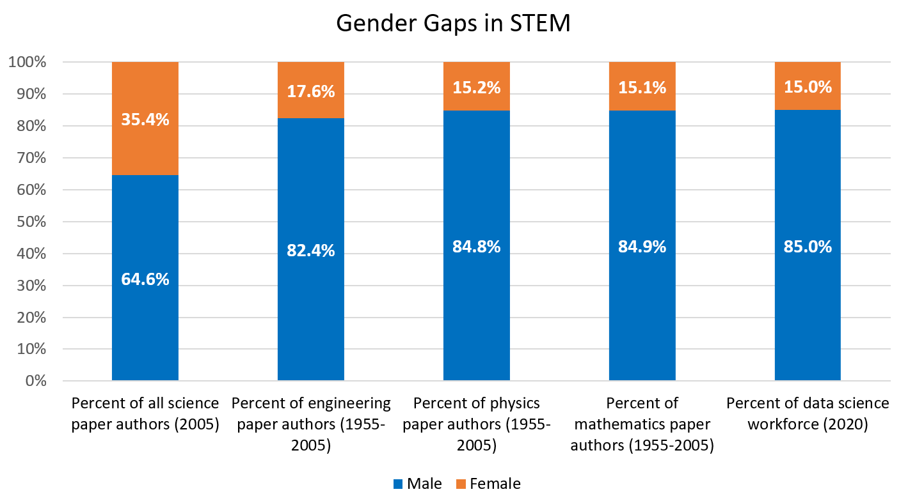**Observational Studies vs. Experiments**

1. One possible cause of gender gaps is **hiring bias.** Provide an explanation for how hiring biases might cause these trends:

From this ____________ data alone, we cannot prove that hiring discrimination is the cause. **Why?**

Confounding variables: Provide ___________________ explanations for trends between explanatory (gender) and response (hiring rates) variables.

2. Name and discuss one **confounding variable** that could also explain the gender gap in STEM:

* Observational study: a study in which data is collected ___________________________ any treatments.
* ______________show cause and effect because they do not control for confounding!
* Experiments: a study in which treatment is _______________ on subjects.
* If well designed, experiments _____________cause-effect relationships by _________________ for confounding variables.
* **Components of Experiments**

**The Jenn/John Study -** Example inspired by [*Advanced High School Statistics*](https://www.openintro.org/book/ahss/)

In this study*, experimenters printed up copies of fake application materials for a science lab manager job. All copies of the application materials were completely identical, except for one thing: the name. On about half of the copies, the application listed the name “John.” The other half had the name “Jennifer.” Experimenters found 127 science lab faculty members and randomly sent them either a “John” (n = 63) or “Jennifer” (n = 64) application. Each faculty member was told that the application was for a real position at their University. The faculty members independently rated the applicant’s “hireability” (1-7 scale) and estimated their starting salary. Experimenters compared these results across the two groups.

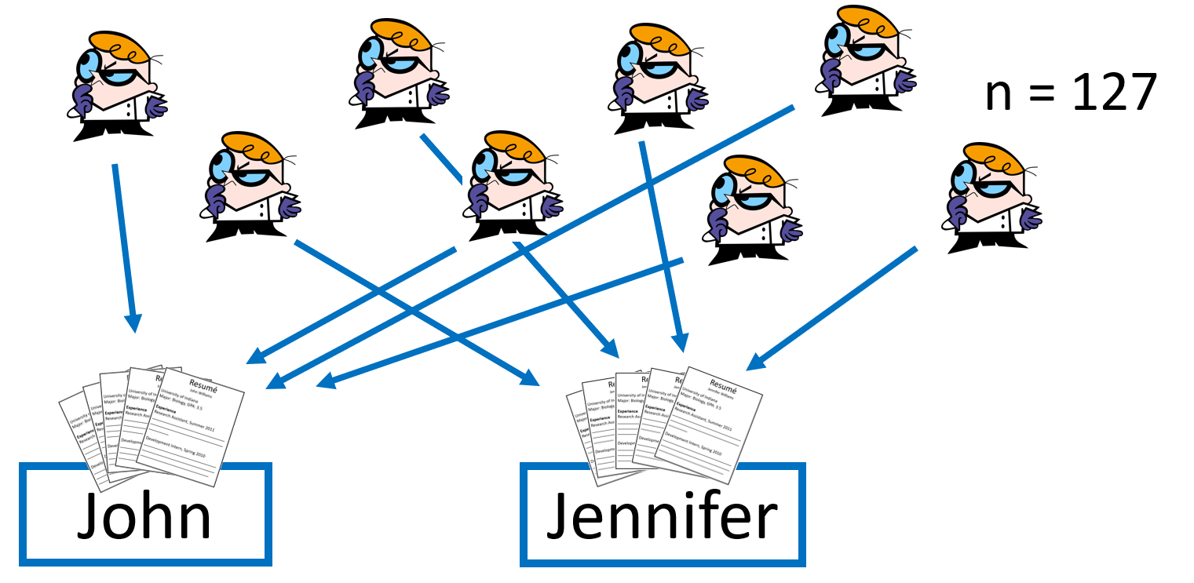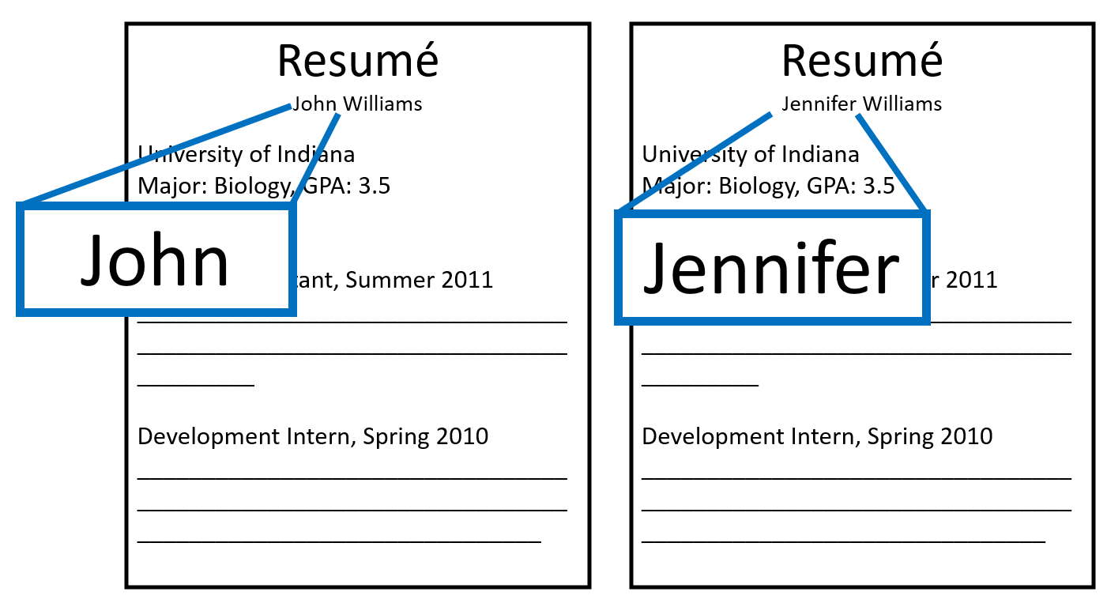

*Moss-Racusin, C., Dovidio, J., et al. “Science faculty’s subtle gender biases favor male students.” PNAS October 9, 2012 109 (41) 16474-16479; <https://doi.org/10.1073/pnas.1211286109>

Experimental units: the ________________________ (person, animal, plant, virus, particle, etc.) that are assigned to different treatments.

*In hiring study:* _______________________

Explanatory variable: the variable that is purposefully __________________. This is also known as the factor.

*In hiring study:* ____________________________

Treatments: the different _____________ of the explanatory variable in the experiment.

*In hiring study:* __________________

Response variable: the measured experiment ___________________ that is compared between treatment groups.

*In hiring study:* ___________________

* **Principles of Experimental Design**
* ________________ of at least two treatment groups
* _____________________________of experimental units to treatment
* _____________________– many experimental units in each treatment group
* ________________ of confounding variables

**1. Comparison**

*a) Explain how* ***comparison*** *is implemented in the Jenn/John study:*

**2. Random Assignment**

a) *Why would it be a problem if I assigned Tier 1 University labs to get “John” and Tier 2*

*labs to get “Jennifer” application materials?*

b) Random assignment tends to ________________ confounding factors, so inferences can be made

about the explanatory variable.

c)

Sampling

Random ___________

🡪 Reduces ________

Experiments

Random ____________

🡪 Reduces _______________

**3. Replication**

a) *Why would it be a problem if I only assigned one faculty member to the “John” group and one*

*faculty member to the “Jennifer” group?*

b) Larger treatment group size reduces the likelihood of differences arising due to chance alone. In

other words, it makes our estimates of treatment effect _______________________.

**4. Control**

a) One way they control for confounding factors is by making the application materials ____________

_______________, except for the explanatory variable (gender).

* **Describing a Completely Randomized Design**

Completely randomized design: An experimental design in which experimental units are assigned to treatments _______________________________________.

**Question:**Describe how you would implement a completely randomized design of the Jennifer/John experiment, with 127 science faculty members.

*Model Response:*

“Assign each faculty member an integer, __________. Write integers 1-127 on identical slips of paper, put them into a hat, and _______________. Draw out 63 slips (without replacement). The corresponding faculty members will receive ‘John’ application materials. The __________________ faculty members will receive ‘Jennifer’ application materials. At the end of the experiment, record faculty members’ rating of applicants’ ‘hireability’ and starting salary estimates. Finally, _______________ these results across the two groups.”

**Discussion**

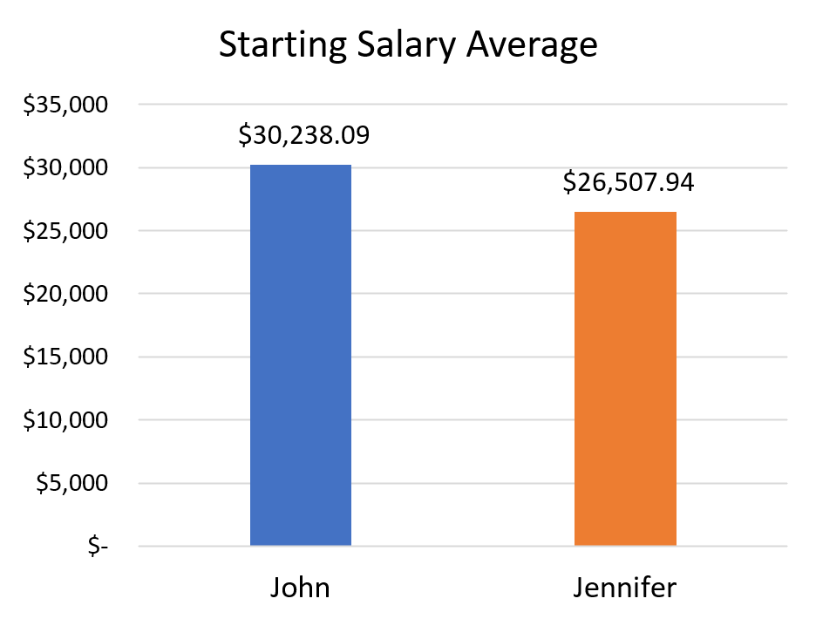**Here’s an estimated summary of the Jenn/John study results:**

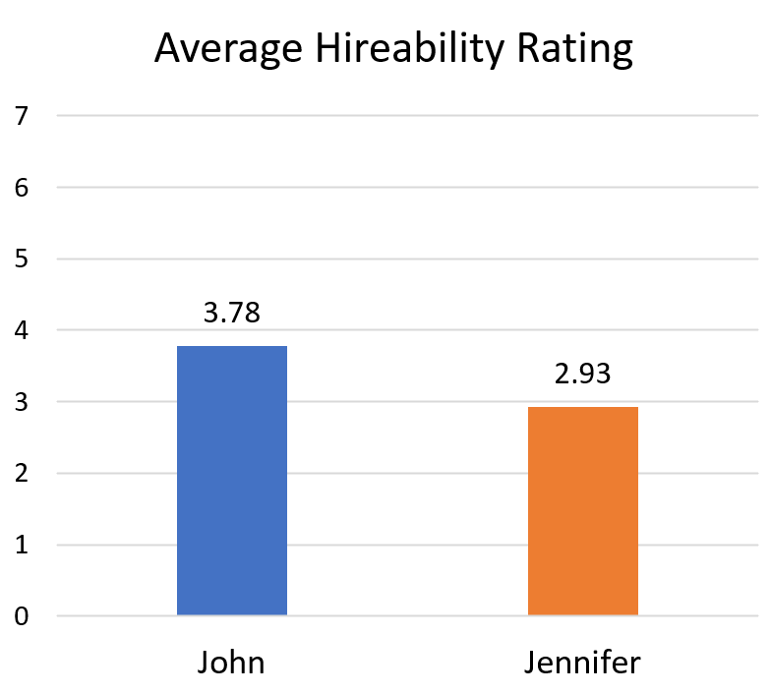

|  |  |  |  |
| --- | --- | --- | --- |
|  | **John** | **Jennifer** | **Difference** |
| Hireability | 3.78 | 2.93 | **-0.85** |
| Salary | $30,238 | $26,508 | **-$3,730** |

The **differences** were found to be statistically significant: so extreme that they were unlikely to happen by ______ ____.

Since this was a well-designed experiment, we can infer that these average differences are ___________by gender bias.

